Why Google Analytics and Google Ads is a Powerful Pairing?
Analytics has become one of the foremost requirements to know your customer and work towards a data-driven marketing strategy, irrespective of the industry you are associated with. If you are wondering about why Google Analytics and Google Ads integration is a powerful pairing, then this blog will answer your question.
Google Analytics: A Brief
Benefits of Google Analytics
Why Google Analytics?
Google Ads: A Brief
Benefits of Google Ads
Google Analytics and Google Ads: Power Combination
How does it work?
Benefits of Linking Google Analytics and Google Ads
Google Analytics: A Brief
The foremost benefit of Google Analytics is knowing user engagement in a better way. So, you get a better understanding of the most read or used segment of your site or app and knowing what’s working and what’s not working for you. Robust reports and dashboards could be your tool for measuring CRM, sales and other elements of customers to get a complete view of your business.
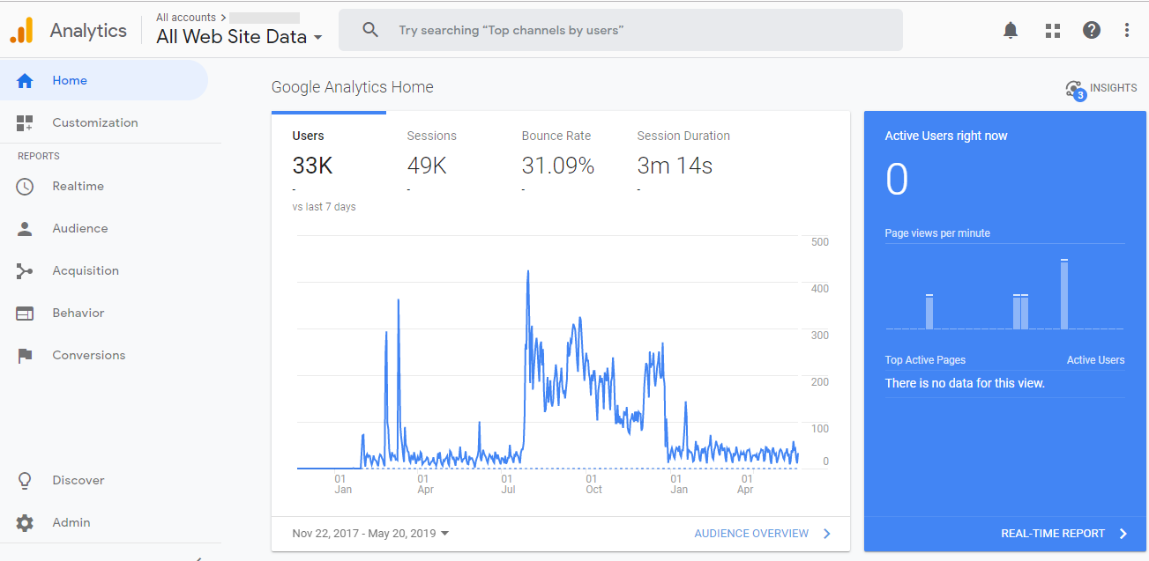

Google Analytics is designed to work in association with Google’s advertising and publishers’ products which in turn will help you connect to your target market or the accurate customer. Analytics could relate to Display and Video 360, Display & Video 360, Optimize, Search Ads 360, Surveys and Tag Manager.
Benefits of Google Analytics
Google Analytics doesn’t restrict itself in providing an insight to your website. Moreover, it contributes to the commercial success of your business. There are ample benefits associated with Google analytics like budget allocation and marketing optimization. The benefits don’t end here there are many more benefits of using Google Analytics which has been mentioned below.
• Marketing Optimization – Optimizing your marketing efforts has been an important part of the business until it is moving in the right direction. Data from Google Analytics will help you to find what’s working and what’s not working. Accordingly, you can invest your time towards optimizing the strategies that are working.
• Improving website usability – Google Analytics’ behavior and conversion reports are most useful to know customer satisfaction in relation to website usability. Behavior report provides an insight into the page with maximum user engagement and requires further investment. The audience report will help improve the usability of the website.
• Identifying the target Audience – Google Analytics report offers user-specific information and insight about understanding your target audience. Some of the elements that form a part of the report for determining the target audience include user location, age, gender, and interest.
• Budget Allocation- The report from Google Analytics help to understand what works for your business and what doesn’t work. This further helps you invest in the aspects that working for your business along with identifying the gaps in budget allocation.
Why Google Analytics?
Businesses across the globe prefer to use Google Analytics for reporting purpose and the reason behind this has been mentioned below.
• It's Free of cost
• The basic set-up is easy
• Easy to use API
• Easy connection of Webmaster tool date to Google Analytics
• Easy to track campaign
• Analytics could be connected to other tools
• Powerful customized report that could be sent periodically through email
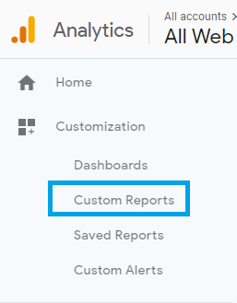
• Flawless export of data to excel
• Annotation could be used with ease
• Custom alert set-up
• Capable of measuring internal site search
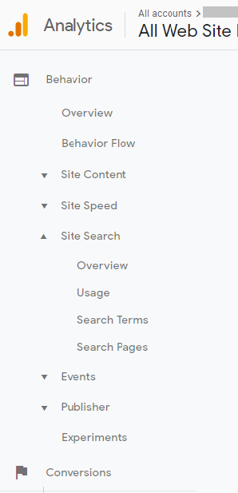
• The profile could be set-up for long term segmentation analysis
• Ad-hoc analysis through the advance segment
• Real-time reporting
• Multi-channel funnel
• Integration with Google Ads is powerful
• Constant monitoring of desktop, mobile and tablet traffic
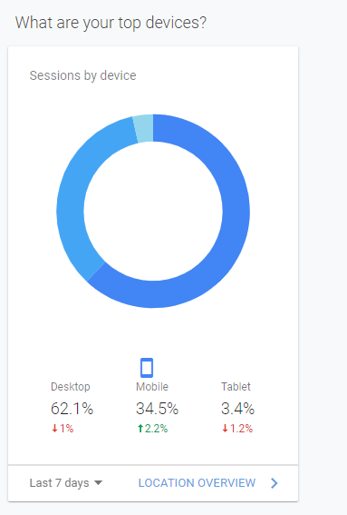
• Easy integration with survey and testing tool
This was about Google Analytics. How about Google Ads? Let’s have a look.
Google Ads: A Brief
Google Ads is the advertising service owned by Google wherein you must pay them to place on the search result in SERP (search engine result page). This saves you from the hassle of working on the ranking of your website as it attains a higher rank through Google Ads.
When somebody looks on Google for a specific term, say 'email verification', Google would toss a list of searches for you. In any case, in the event that you look carefully, you will see that the top and the bottom results are generally ads.

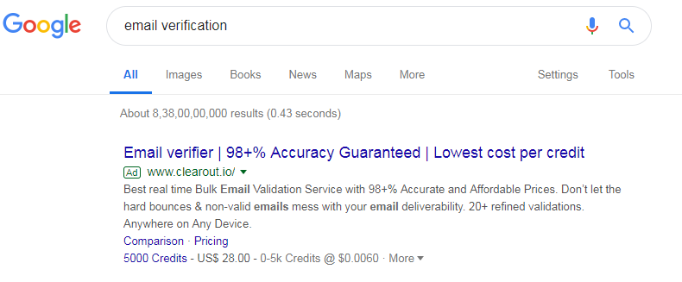
In simple Google Ads is running ads based on keywords or audiences. So, if you run ads on Google Ads your website will appear at the top of the search engine or to the bottom.
Benefits of Google Ads
• It's faster than SEO- Though both Google Ads and SEO are search engine marketing strategies, Google Ads are faster. It focuses on multiple keywords and facilitates activating and deactivating the campaign.
• Google Ads helps to increase brand awareness- It increases the brand awareness of your business through boosting traffic, clicks, and conversions.
• Google Ads help to reach more customers- Adding Google Ads for your business to your marketing strategy helps you to reach out to the customers through Google.
• Reconnecting with website visitors- It is attributed as the best feature of Google Ads as it has the capability of reconnecting with the website visitors.
• Remarketing through display network- Advertisers can reach out the visitors in different advertising-supported websites through banner images.
Google Analytics and Google Ads: Power Combination
Google Analytics and Google Ads is the most powerful tool for online marketing at present. With a robust amount of information available through these tools, you can get the hand of an immense amount of data. Moreover, both these powerful tools are from the same organization making the combination an easy task. Let’s understand how it is:
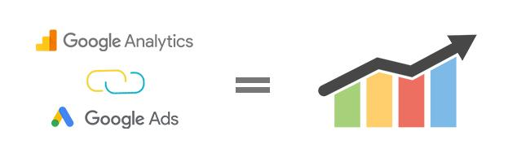
Google Analytics helps you gain a deeper understanding of your customers also, how they're engaging with your site, content, and products or services. Analytics gives you more insights and the ability to give the customers something to engage rapidly on your site by its Google Ads integration. The integration helps you to make ads to market your products or services, then get them in front of people likely to buy from you across Google Search, YouTube, and Google’s network of partner sites and apps.
The linking between Google Analytics and Google Ads helps you get a clear perspective on how your ads are prompting conversions and thereby you can rapidly alter creative and bidding to create insights-driven ads. In addition, you can engage your customers with customized messaging from the most valuable customer segments. You can likewise utilize Google Analytics and Google Ads together to pinpoint to get deeper insights, create smarter marketing, and drive better business results.
Simply, what you get from Google Analytics and Google Ads linking is:
- Insights-driven marketing: You'll get a better understand of how effectively your ads are leading to conversions.
- Optimized bidding: You'll get access to a new set of reports to better understand what happens after a customer clicks an ad.
- Customized messaging: You’ll be able to engage your customers by delivering customized messages to drive more conversions.
- Advanced machine learning: You’ll be able to find a list of your most valuable customers with Smart Lists to dynamically adjust your Google Ads campaigns to reach those customers.

How does it work?
When you link a Google Ads account to Google Analytics, anybody with access to the views you selected throughout linking is able to see the imported Google Ads information.
In like manner, in the event that you import Analytics information, (for example, goals and transactions, metrics, or remarketing lists) into your Google Ads account, anybody with access to that Google Ads account is able to see your imported Analytics information. You'll have the option to see this information in the Conversions segment of your Google Ads reports.
Remember that once Analytics information (for instance, goals) has been imported to Google Ads, it is liable to the Google Ads terms of service.
Benefits of Linking Google Analytics and Google Ads
Linking Google Analytics and Google Ads allows you to:
- Improved Google Ads reporting in Google Analytics
- Importing Google Analytics goals and transactions to Google Ads
- Import Analytics remarketing audiences
- See Google Ads data in your Analytics reports.
Let’s have a detailed look for Google Analytics and Google Ads to be considered as a powerful combination has been mentioned below.
Improved Google Ads reporting in Google Analytics
With the ease of integrating with each other, the combination provides a report with more granular data. The Acquisition report section of Google Analytics is dedicated to the performance of Google Ads, which is not available to the user without linking Analytics and Ad. This facilitates Google Ads data with Google Analytics data for better insight and optimization. You can also get an insight into the different key behavior that is not visible solely through Google Ads.
Google Ads Analytical data interface
The combination will let you avail some more columns in the Google ads interface. You can modify the columns to include metrics like
- Bounce rate
- % of new sessions
- Sessions
- Average session duration
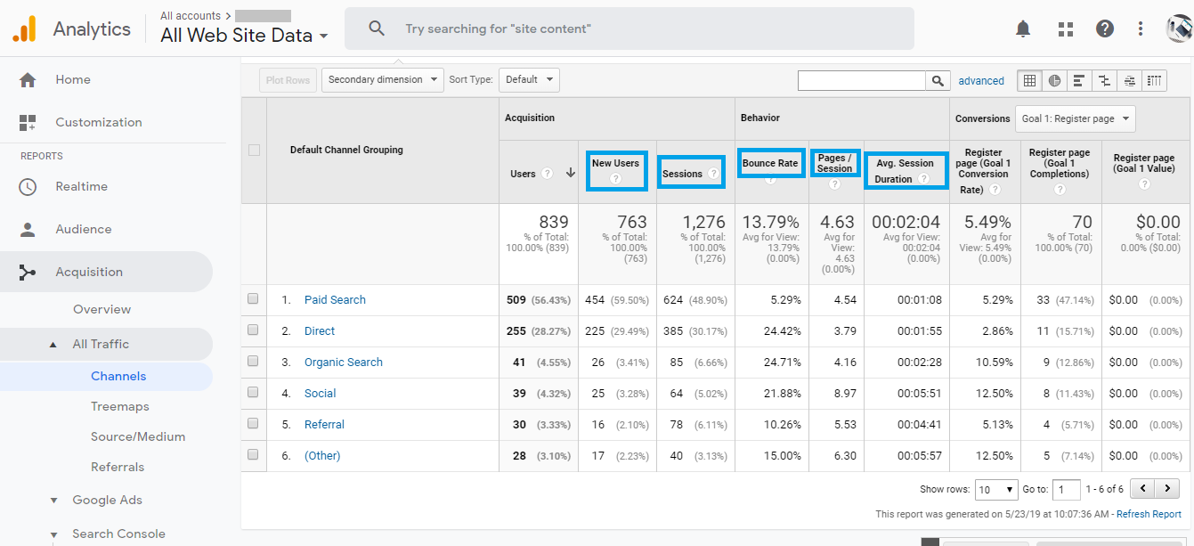
These metrics would be of great help for ad copy tests or for keyword performance review. If the conversion rate of your website is low, these statistics will help in covering the gap. A quick check of these additional columns will provide an insight into engagement stats for the Google Ads interface and help to make the required change.
Importing Goals from Google Analytics to Google Ads
While conversion tracking you can import the Analytics goals into Ads through this pairing. This could act as the replacement for Google Ads conversion tracking. The Google Analytics Goals will help you import the data into the Google Ads interface with an average delay of 3 hours in stats. So, it’s great to optimize the real-time data and it’s just fine to optimize the performance of the previous day.
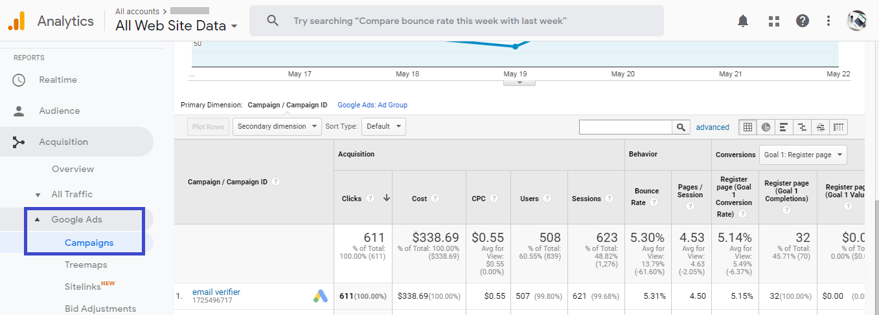
Benefits of bringing your Google Analytics goals
Importing your Google Analytics goals into Google Ads offers a couple of advantages. They include:
- Access your Google Analytics conversions and data related to your Google Ads clicks.
- You can view the Google Analytics conversion data in Google Ads.
- Getting the Conversion Optimizer access to information that helps in optimizing bids, possibly expanding conversions and bringing down expenses.
Import Analytics remarketing audiences
There is a constant growth of the remarketing audience with the pairing of Google Analytics and Google Ads.
The integration with Google Ads helps you to reconnect audiences that are probably going to convert based on user behavior on your site or app. The integration also offers extra alternatives that increase standard Google Ads Remarketing to:
- Make remarketing lists dependent on Analytics data
- Build your audiences from Analytics metrics and dimensions (for instance, Session Duration, City, and Goal Completions)
- Connect users who perform a specific sequence of actions on your site (for instance, users who visited on your product page and then clicked the “add to cart” button)
Bottom line
Linking Google Analytics and Google Ads is the most powerful combination and it offers benefits for both channels. In short, by linking Google Ads with Google Analytics you can:
- View website performance data
- Import goals and transactions into Ads
- View Google Analytics website engagement data in Ads
- Create remarketing lists in Analytics to use in Ads for targeting specific audiences
- Automatically view Ads click and cost data in Google Analytics account along with your site engagement data
The integration of Google Analytics and Google Ads is not time-consuming and is a great way to sharing data and audience for better reach to the customers and brand awareness. If you are seriously thinking of linking your Google Analytics to Google Ads account, it’s simple and there are resources available online to accomplish the task.

